

Project ACS
Functional Specification
Accelerated Content Store
Docbase Version 1.2
06/15/2005
Alex Oscherov

Revision History

Docbase  Version | Revised  Date | Revised By | Revision  Description
1.0 | 04/07/2005 | Alex Oscherov | Initial draft
1.1 | 04/15/2005 | Alex Oscherov | Revised based on group review.
1.2 | 06/15/2005 | Alex Oscherov | Added chapter about CACS
Functional Specification Template Version: 1.2
Table of Contents
1.0 Overview 5
1.1 Project Overview 5
1.1.1 Terminology 5
1.1.2 Reference Documents 5
2.0 Functional Description 6
2.1 Top Level Functionality 7
2.1.1 Client communication module 8
2.1.2 Decryption module 9
2.1.3 File system module 10
2.1.4 Configuration module 11
2.1.5 Miscellaneous modules 12
2.2 Deployment model 13
2.2.1 ACS installation 13
2.2.2 ACS configuration 13
3.0 Caching Accelerated content Store (CACS) 14
3.1 Module difference between CACS and ACS 16
3.1.1 Client communication module 16
3.1.2 Decryption module 16
3.1.3 File system module 16
3.1.4 HTTP client module 17
3.1.5 Configuration module 17
3.1.6 Miscellaneous modules 18
3.2 CACS deployment model 18
3.2.1 CACS installation 18
3.2.2 CACS configuration 18
4.0 Internationalization (I18N) 19
5.0 External Interfaces 19
6.0 Dependencies 19
6.1 Dependency on DFC 19
6.2 Dependency on Java DMCL 19
6.3 Dependency on servlet container 19
6.4 Dependency on DA 20
6.5 Dependency on UCF 20

Overview

Project Overview
Documentum users increasingly using web based solutions such as Webtop to access Documentum Docbases. As a result often now users getting access to the very remote Docbases. For example users in Australia can through Webtop access Docbases physically situated in USA and so on. In the current architecture all information (content and metadata) to the user’s computer gets transferred through application server physically situated closely to the Docbase. Close location of the application server to the Docbase is defined by the chatty nature of communications between them. So in many cases remote users are forced to long delays in the cases of transfer big contents over long distances through the slow networks. Our experiments showed, depending on the network, transfer time for 10 Mb file can differ between 10 seconds and 170 seconds.
“Distributed” project addresses this issue by allowing placing special servers containing Docbase content in the places where content can be transferred over the fast networks between user computers and these servers. The goal of “Distributed” project is to develop these accelerated content store (ACS) servers and enable their use by Documentum products.
“Distributed” project consist of three major parts: Content server extensions, DFC/UCF extensions and ACS. This document describes functional specification for ACS. ACS serves as an intermediate step on the way to using content caching service (CCS).
The first release of ACS will address only accelerated content download. Accelerated content upload will be addressed in the future releases

Terminology
Client The end user machine – where the browser executes in a Web environment, or where application uses web services.
Server Application server that server Docbase requests
ACS Accelerated content store

Reference Documents
- Distributed content – server specification. By Eric Lundblad
- Distributed content – DFC\UCF specification. By Alex Oscherov

Functional Description
ACS main goal is to speed up access to the Docbase content for the remote users. ACS can serve one or several remote content servers (RCS) and/or content servers (CS). The major difference of the ACS from the future CCS is that it requires presence of RCS/CS on the local network and assumes presence of the DFC/DMCL. ACS uses file store provided by RCS/CS to retrieve content. ACS allows many too many relationships with CS. Single ACS can serve multiple CS and also single CS can use multiple ACS to accelerate remote content access. ACS uses file path mapping to access files on RCS/CS. Mapping schema between RCS and ACS is externalized and can be configured by the administrator on the ACS configuration file. ACS will support inbound and outbound content transfer operations but in the initial release only outbound operations will be supported. ACS won’t be supporting encrypted file store.
ACS server provides multiple protocols for communications with client. In the initial release it will support HTTP/HTTPS, later will be added support for FTP and SMB. If necessary other protocols can be supported after that. Single instance of ACS could use multiple communication protocols but due to underlying protocol implementation limitations some combinations of protocols will be unsupported. For example support of HTTP protocol will require use servlet in some kind of HTTP server. It could become incompatible with running FTP protocol in the same process space. Choice of what protocols should be used by the ACS can be done externally using ACS configuration file. Size of the files that ACS is capable to transfer is limited only by the hardware limitations and also architecture of the most modern computers doesn’t allow serving files larger than.
ACS supports lazy data population as a main mechanism to populate data from the central content server to the remote location. ACS gets information that content is not present locally and before serving it ACS should get it from the central CS. In this case ACS asks local RCS to perform “surrogate get”. Use of the “surrogate get” requires establishing distributed store with at least two locations one on CS and another on the RCS. Upon receiving file in the local file store of the RCS ACS returns it to the client.
ACS supports only non-compressed and non-encrypted files stores in the initial release in the future it will support only also compressed and encrypted file stores. Ability for ACS to support “Centera” will be evaluated later.
ACS provides the same level of security that currently exists for web based Documentum applications. This security solution involves protection against URL tampering i.e. attempts by malicious clients to change built by CS URL so to get access to the files they have no rights to and also authentication of the URL source i.e. verification that URL was originated on the valid CS.
In the case when ACS client is UCF ACS provides additional services. ACS upon request can compress transferred content thus reducing amount of transferred data also it will be able to perform following additional actions
- Accept content compressed by UCF and uncompress it before storing on the file system.
- Recover from the network errors by restarting transmission process from the place where it was interrupted not from the beginning of the file.
ACS will know about presence of UCF because UCF will pass information about its presence in the URL.
[Here are special capabilities when working with other clients - Arvindh]
Also HTTP communication module supports “Ranges” header according to HTTP 1.1 RFC. Using this header allows intelligent clients to get access to the pieces of content without downloading whole content. For example PDF browser plug-in can initially show only first page of the big PDF document and then if user requests so immediately provide server with ranges for the last page of the document without downloading all intermediate pages.
ACS exposes itself on the network by registering with the Docbroker. ACS periodically updates its status on the Docbroker thus allowing knowing if it is running or not. These calls are made using DFC.
DA should support ACS configuration creation and changing on the CS. Also ACS should have its own UI for configuration and presentation of server status and statistics.

Top Level Functionality
ACS communicates with both sides of the Documentum web application (Figure 1). On one side it communicates with client browser providing it with accelerated access to the content. On the other side it communicates with the CS/RCS and directly with the file system.
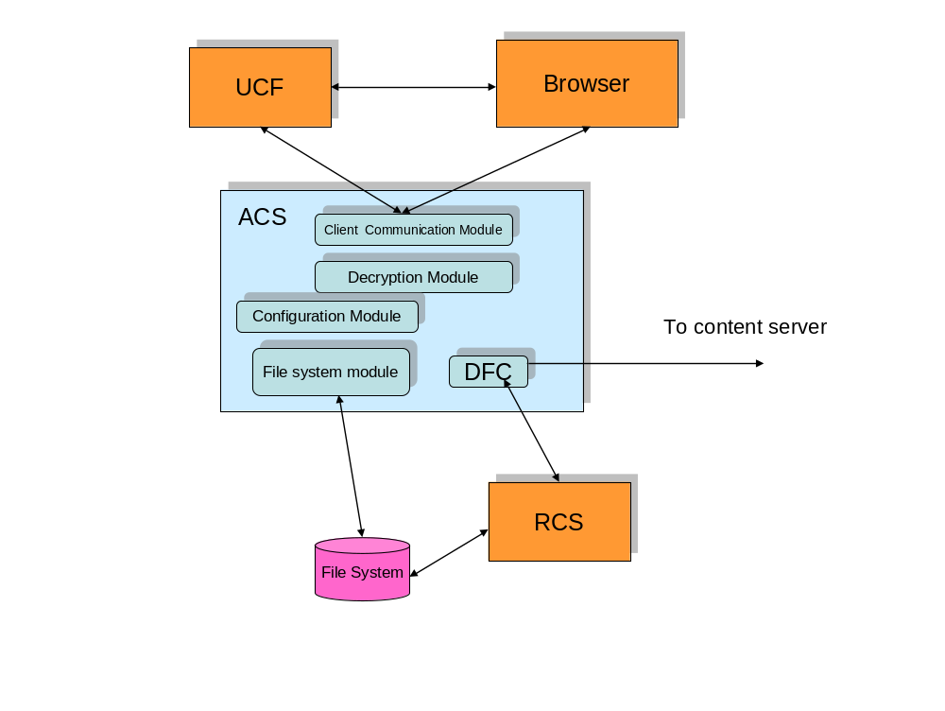 Figure 1 – ACS view
On the high level ACS consist of four major modules. These Modules in interaction with each other provide full ACS functionality.

Client communication module
Client communication module is responsible for retrieving and parsing information from the client. In the initial release only communication module for HTTP/HTTPS protocols will be implemented. Client communication service provides following major services
- Provides single mechanism for all other modules to communicate with clients, independent of type of protocol supported by client (i.e. HTTP, FTP or anything else).
- Wraps information so that it can be passed to the client in the protocol it expects.
- For UCF client it supports data compression on the request by UCF.
- Also for UCF client it provides smart recovery in the case of interrupted data transmission. Client communication module can request UCF to continue data transmission with some offset and also can process UCF command where UCF asks to restore data transmission with the offset of the initial stream.
- Support for “Ranges” header in the HTTP 1.1 protocol thus allowing intelligent clients to show different pieces of the content without waiting for full download. Communication module can support “Ranges” for UCF client as well.
Type of the protocol supported by the instance of client communication service is externally configurable directly through ACS configuration file (TBD when we will have special UI based configurator for ACS?). Upon instantiation client communication module negotiates with configuration module type of the client communication protocol. In the simple case when installation supports only one protocol this protocol gets chosen automatically. In more complicated cases when several protocols can be supported administrator has to choose one of them.

Decryption module
To protect content on the RCS from the unauthorized access through ACS, part of the URL that contains absolute path to the content on the file system gets encrypted using symmetric encryption key. This key gets created on the CS specifically for purpose of supporting ACS communications and gets saved with other encryption keys such as “login ticket” key. Sensitive part of URL generated by CS gets encoded by this key. There are two possible approaches to how ACS gets access to this key.
- Through special DFC call “export” analogous to the call to export “login ticket” encryption key. This key requires administrator privileges on the CS and ACS can be granted these privileges. For additional security key can be encrypted with password and DMCL can use SSL secured transport for communication between CS and ACS.
- The alternative solution could be saving this symmetric key as a regular “sys_object” in the Docbase and assigning it ACL that only ACS administrator and CS administrator could have access to it. The benefits of this approach is that CS administrator privileges should not be saved any more on the ACS only privileges that would allow to access to this special ACL. Another benefit of this approach is that it doesn’t require any changes in DFC/DMCL because regular DFC calls could be used to retrieve “sys_object”. (TBD it needs additional discussion with Kevin Lewis)
Independent of what solution will be chosen ACS should have some special privileges for all content servers that it supports. In the first case it should be login name and password for CS administrator and in the second case it should be some special login name and password for ACS administrator on the CS. Also in the case when system administrator login name and password or special credentials for the ACS administrator get changed on the content server these changes should be passed to the all ACS servers to which this CS is projected to. This can be done either manually (which means that CS administrator has to notify ACS administrators over the phone, mail or by some other means) or by CS sending special command to the ACS. This second approach has several unresolved issues
- It means that content server should be able to send commands in whatever protocol any given ACS supports
- It is not clear how to notify later ACS server that were shutdown at the time when password was changed on the CS.
- Some ACS even when they were up and running didn’t get any requests from the clients using this CS so they never loaded symmetric key from it. And won’t be able to decrypt the command.
Decryption module doesn’t save persistently encryption key anywhere on the ACS. After receiving this key from the CS it caches it into memory. It means that either at start time or later upon necessity decryption module requests configuration information about all CS that this instance of the ACS supports. This information about each server should include information about login name and password for each CS that will allow getting access to the symmetric key. Using this information decryption module gets encryption keys from each CS. When CS changes symmetric key sometime while ACS is running, ACS will be unable using old symmetric key using old symmetric key to decrypt information from the CS, in this case before bailing with exception decryption module should try to load new symmetric key from the CS.
Information about administrator login name and password is sensitive so configuration module should keep it encrypted on the file system and in the folder where only privileged users such as ACS administrator can access it.

File system module
File system module allows direct access from ACS to the files stored on multiple RCS situated on the same LAN. Major task for the file system module is translation from the absolute file paths on the RCS file systems to mapped path on the ACS. It allows putting RCS and ACS on different platforms (For example RCS can be running on the UNIX and ACS on Windows). Underlying mapping technology will be different depending on the operating system. It can be NFS for UNIX and UNC for Windows but underlying technologies hide most of the differences. File system module performs following major tasks:
- Conversion between Windows and UNIX file path notations
- Mapping between ACS file system and multiple RCS file systems
- Supports resource forks for Mac clients. I.e. for the cases when client is Mac and there is no resource fork file present (For example because file was created on Windows) this module is responsible for automatic creation of the default one.
Mapping between ACS file system and RCS file systems performs externally through configuration file provided by system administrator. Access to this mapping file performs through configuration service.

Configuration module
Configuration module provides support for all external configurations used by other modules. It has an API that allows other modules get access to the externally configurable information without really knowing where and how it is stored. ACS has several groups of parameters that require configuration
- Client protocol – this group of parameters specifies what type of protocol this instance of ACS supports and what parameters of this protocol. For example can be configured to support HTTPS protocol and use port 8443. This part of the configuration can be kept in the plain text configuration file.
- Mapping between RCS and ACS file systems. This configuration allows ACS access files denoted in absolute path for RCS file system. In the simplest case when ACS and RCS are installed on the same computer no mapping is necessary and configuration module should support it as a default case when no mapping configuration file is found. In the other cases administrator can specify mapping between different file systems using special configuration file.
- Configuration that keeps login name and password for ACS administrator that will allow ACS retrieve symmetric key for URL decryption. This information should be kept on the ACS file system in the encrypted form. ACS can use its own encryption facility or in the initial release use facility provided by DMCL for password encryption.
- Configuration that specifies what Docbrokers should be projecting ACS and what is the frequency for the status update. Apparently a generic rule is that ACS should be projected on the same Docbrokers on which CS is projected so DFC that serves requests from the CS could validate state of the ACS. For the list of Docbrokers the best is to use ACS configuration object kept on the all CS that use this ACS. Apparently this means That ACS should locally know all CS it works with but this information should be saved anyway to keep information about login names and passwords.
- Generic configuration parameters – these parameters include
  - Configuration for the tracing
  - Configuration for the debugging
  - Logging configuration
Maybe not in a first release but in the nearest future ACS configuration module will need UI based utility to provide easier way to handle several configuration files possibly placed in the different locations. This UI based utility should be Web based so that configuration could performed remotely and be protected by the password so that only authorized personal could perform configuration.
Due to the security requirements login names and passwords should be kept in the separate encrypted file. All other groups of parameters could be kept in the separate files or the same file with XML structure that allows combining different groups of parameters. Each approach has its own advantages
- For approach with multiple separate files they can have simple structure that is easy to understand. Different people can have different roles and know and care only about files important to them.
- For approach with the single configuration file it is more maintainable (It is easier to find one file than multiples). Also for UI configurator it would be easier to find and parse one XML file than multiple files with different structures (For example some files can have structure of java property files and some XML). Final solution TBD.

Miscellaneous modules
Several modules were not shown on the Figure 1 because they are normally present on most servers and not specific to ACS. These modules include
- Logging module that allows logging information about server functioning. Through the configuration this module allows different levels of logging (“fatal”, “error”, “warning”, “info”, “debug”). Reusing log4j for this module implementation will provide with most flexibility. It would be beneficial to implement at least parts of logging using AOP approach so that customers could be able to specify points (cross points in terms of AOP) on their own.
- Tracing module allows tracing server code running in the cases when some problems happen on the customer side. Easiest solution is that tracing module reuse logging module solutions for tracing purposes. The cleanest from the design stand point would be implementing tracing using AOP. We have experience in this area and should probably go this way
- Statistic and monitoring module allows collecting information about server performance such as how many requests was processed, what was average transfer speed and so on. This module should have Web based UI so that remote administrator got able to retrieve this information in the easy readable form. The most flexible will be solution where this module implemented as java management extensions (JMX) thus allowing our customers develop their own UI solution including those that encapsulate view of this module into existing UI. Probably this feature won’t be ready in the initial release but should be accounted for in the future releases.

Deployment model
ACS deployment includes installation and configuration. ACS could be deployed as a standalone piece or as a part of larger deployment. Starting with release 5.3 SP1 ASP should be part of the standard installation for each CS or RCS.

ACS installation
ACS could be installed independently and for this purpose should have its own installer. It also can be installed as a part of CS or RCS installation and for that case it should allow for ACS installer to be called from the CS/RCS installer. If ACS supports HTTP/HTTPS clients – and this is the most common case installer should have an option to install HTTP server as a part of ACS installation or connect ACS to the existing servlet container i.e. install ACS as a new application on the existing server. List of the servers supported by the ACS installer can initially include only Tomcat but get later extended by HTTP servers that support servlet containers. On the Windows platform there should be option to install ACS as a Windows service.

ACS configuration
ACS configuration is a necessary step of the ACS initial deployment but also can be performed later if/when administrator decides to change ACS configuration. Some of the ACS configurations could be performed only on the stopped server, i.e. they can be done on the running server but wouldn’t take effect until ACS restart. These include
- Client communication module configurations i.e. HTTP port, base URL
- ACS to RCS file mapping
- Changing login names and passwords for CS and adding new CS
The configurations for tracing and monitoring can be changed dynamically. When called on the running server they take effect immediately without server restart. All ACS configuration parameters can be separated in two big groups – parameters configured locally on the ACS itself and parameters configured remotely on the CS on the behalf of ACS. All these parameters on the CS configured as the part of configuring ACS configuration object. Every ACS that provides services for CS has its own configuration object on this CS.

ACS configuration object
ACS configuration object should be configured by the ACS administrator. S/he should do it using DA. Using of the DA assumes that ACS administrator has administrative rights on the CS. DA will be extended to support full ACS configuration object. Full description of this object can be found in the “Distributed content – server specification”. Essentially it keeps all information necessary for CS to choose this ACS for distributed operation and it includes if ACS supports read/write or read only operations, what type of storage ACS supports, what is the location of the ACS and so on.
When ACS gets installed as a part of RCS/CS installation installer can automatically create ACS configuration object because it has all necessary information except for location. This information installer can ask for. Later administrator can change default values supplied by installer.
For the independently installed ACS installer can save default parameters into special configuration file (format TBD but probably XML) and then ACS administrator can have special DFC based utility that will create this ACS configuration object on the CS of administrator choice.

ACS local configuration
It would be very beneficial if there is UI based tool for local ACS configuration on the other hand supported protocols configuration is bind to the information specified in the ACS configuration object (base URL) so the best solution would be that the same utility that specifies this parameter in the ACS configuration object has to configure locally supported protocols. For the case when ACS installed as a part of RCS installation on the same computer there is in the default case no need for path mapping between RCS and ACS. In the case when ACS is physically situated on the separate computer from the RCS the ACS administrator should provide path mapping in a configuration file stored on the ACS local file system. UI tools or just straight file manipulation this mapping should be done manually. Format for this file will be XML and for additional reliability it will have XML Schema. Saving login names and password for accessing symmetric keys should be performed by the special utility so that this information gets stored encrypted in the protected folder.

Caching Accelerated content Store (CACS)
In addition to the using ACS as a way to speed up access to the content for the remote users another approach is to use content caching utilities/appliances. This approach is especially beneficial for the small remote branch offices that are unable to have IT staff necessary to manage ACS. The general architecture of the distributed content transfer using CACS is shown on the below.
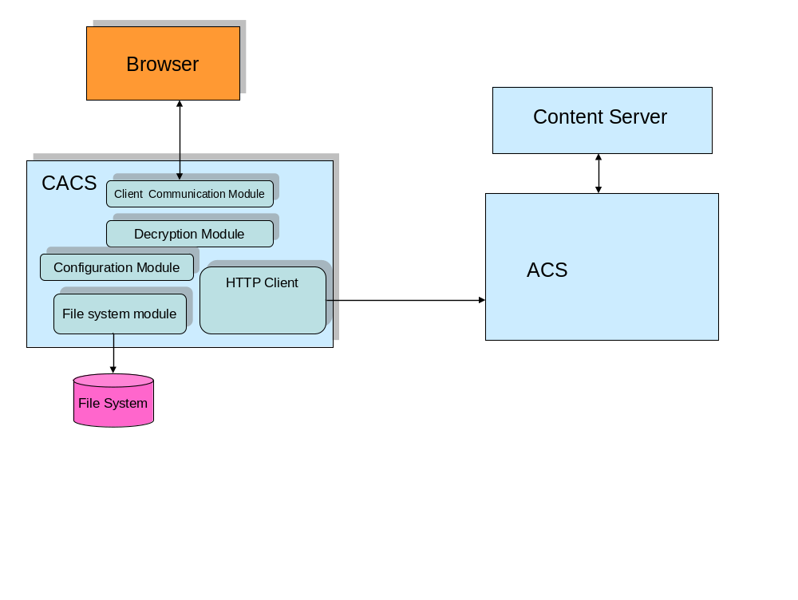
Figure 2 – CACS view
As shown on this figure the major difference between CACS and ACS is absence of CS/RCS located physically close to the CACS and presence of the of the HTTP connection to the remotely situated ACS. While functionally close to the ACS CACS have several areas where it is quite different from the ACS
- CACS is a caching solution - presence of the content on the CACS local file store is defined by the CACS internal logic and in general is not synchronized with the content on the CS/RCS.
- CACS doesn’t have DFC and uses HTTP access through ACS for all necessary information including content to be cached and public key certificates necessary for the URL verification
- CACS assumes minimum local configuration and very simple installation. Most of the necessary information CACS gets from the URL passed to it by the browser or by calling remote ACS.

Module difference between CACS and ACS

Client communication module
Client communication module stays mostly the same between ACS and CACS. The major difference is that any content request to the CACS should contain as one of the parameters the URL of the ACS where CACS can retrieve content in the case if it is not present in the local cache of the ACS. The necessity to have this information is based on the fact that application server (WDK/DFC) can’t make assumption about presence of the any piece of content on the CACS.
Also for each piece of content potentially different CS/RCS can be used as the closest source. For example for one content RCS1 can be the closest source but may be doesn’t have another content and would be forced to perform “surrogate get” to get it in this case DFC can supply HTTP for some RCS2 that already contains this content as the closest source.
Unlike ACS CACS doesn’t have access to DFC/DMCL so it can’t project its status through Docbroker. Instead it will support special command that could be sent by the application server to verify status of the CACS. In the case when CACS uses HTTP/HTTPS protocol to communicate it will have simple “ping” servlet call to which will verify that CACS is up and running. In the future releases this servlet will be extended to provide more thorough information about CACS status.

Decryption module
Decryption module will stay essentially the same between ACS and CACS. Content server will digitally sign the same information independent what will be used to retrieve it CACS or ACS. The only difference between ACS decryption module and CACS decryption module is that CACS decryption module gets public key for digital signature verification by making special HTTP calls to the ACS to get certificate of the public key.

File system module
File system module is significantly different between ACS and CACS. While ACS relies on the file system management provided by CS/RCS CACS file system module should effectively manage content on the file system on its own. This management includes following activities
- Creating file structure that by the content qualifications such as object ID, format and so on allows to uniquely identifying the content. For CACS we use object ID, format, page number, page modifier and cache ID which is either content ticket or content ID
- Support multiple content stores i.e. allowing use of multiple roots (for example C:\, D:\ … on the Windows) to use as storage for content
- Support quota of hard drive space allocated for cached content including cleanup algorithms for removal some cached content when quota is achieved based on last use, size and so on.
- Provide housekeeping facilities for removal long unused content.
- Requesting content from the HTTP client module in cases when content was not found in the cache.
- Provide content error recovery in cases when cached files get damaged due to software or hardware problems.

HTTP client module
This module is unique to the CACS and is not present in ACS. Main function of this module is to retrieve in the reliable way content from the remote ACS over the HTTP by request of File System module. This module include following major functionality
- Form URL to ask ACS for the content absent in the local cache
- Provide data transfer for the unlimited size content with the ability to recover broken connection and continue data transfer from the position where it was interrupted.
- Provide transfer for public key certificate from the ACS upon request from the decryption module
- In the future provide configuration parameters from the ACS to CACS.

Configuration module
CACS differs from the ACS that it requires very little configuration. So configuration module for CACS while have multiple parameters that may be tuned for most effective use of the cache file store requires only two of them being configured
- Disk space quota
- Content stores – i.e. where on the file system will be roots of the caches (For example (C:\Store1, C:\Store2)
It is important that unlike ACS configuration of CACS configuration won’t contain any sensitive information such as login names and passwords thus allowing installing it in less secure environments.

Miscellaneous modules
CACS will have the same set of modules including logging, tracing and in a future statistics that ACS will have. In terms of requirements to these modules there are no significant differences between ACS and CACS.

CACS deployment model
CACS deployment model differs significantly from the one for ACS. CACS expected to be deployed in places without extensive IT support and can be distributed as an appliance i.e. it can be preinstalled on the computer and in this case it shouldn’t require any additional on-site configuration.

CACS installation
As mentioned before CACS could be distributed as appliance. In cases when it gets installed on the existing computer the installation will be very straightforward.
- CACS installer should check if servlet container (Tomcat in the first release) is present on the computer and if it is present it should provide an option to install CACS as an additional application on this servlet container. Alternatively installer should initially install a servlet container
- After copying all binaries installer should prompt for two parameters:
  - File store roots
  - Cache quota
While CACS will have several other configuration parameters those have sensible default values and normally can be left alone.
After CACS gets installed and running in the branch office this office should notify central IT about new CACS. For CACS to get used as a cache by CS, IT administrator has to create ACS configuration object in each Docbase that is going to use this facility. During this ACS configuration object creation administrator will associate CACS with some network location. If CACS is placed in a new network location than administrator should initially create this network location in the “Global Registry”.

CACS configuration
In the initial release additional (after installation) CACS configuration will be performed by changing local properties file. In the future releases CACS will provide Web based interface for configuration.

Internationalization (I18N)
The UI components of the ACS should be internationalized. It can be done using Java resource bundles. Outside of UI ACS have no internationalization issues.

External Interfaces
ACS is considered as an application that provides no external interfaces for extensions or uses some of ACS functionality outside of server itself. Public interfaces that can be used by developers who want to extend ACS functionality for example add support for a new client protocol will be defined later during design stage.

Dependencies

Dependency on DFC
ACS relies on the presence of DFC for the following tasks
- Performing “surrogate get”
- Accessing ACS configuration object
- Retrieving symmetric encryption keys
These dependencies are shielded through special wrapper so that in a future they could be removed so that ACS won’t be depending on DFC

Dependency on Java DMCL
ACS relies on Java DMCL project to project itself on Docbrokers.

Dependency on servlet container
ACS uses servlet container to provide access to support HTTP/HTTPS protocol. ACS installer will provide choice to install a new container or use existing one. From the ACS itself it can be any servlet container but for deployment simplification only Tomcat will be initially the only one supported.

Dependency on DA
ACS will rely on DA for configuring ACS configuration object on CS. While for initial default configuration ACS will use special script to populate ACS configuration object but for individual changes it will rely on DA.

Dependency on UCF
As mentioned before ACS will provide additional services to UCF clients outside of standard services provided by HTTP 1.1

